EDQ for Salesforce Commerce Cloud

Version 19.1.0

Test Cases



Contents

Global Intuitive 3

Test Case #1 Single line address 3

Verification Engine 6

Test Case #1 Valid address 6

Test Case #2 User interaction address 9

Email Validation 9

Test Case #1 Invalid email 9

Test Case #2 Valid email 11

Test Case #3 Invalid email 12

Phone Validation 14

Test Case #1 Invalid phone 14

Test Case #2 Valid phone 15

Test Case #3 Invalid phone 17

# Global Intuitive

## Test Case #1 Single line address

Configuration on the Business Manager should be:

* Preferred address search engine = Global Intuitive.

*This test should work with either “Both” or “Global Intuitive” options.

Once your logged into your store go to you profile and add new address; start typing down an address in the address input field “Address 1” and global intuitive will display some options to match the address your typing down; select the correct address your typing down from the list above.

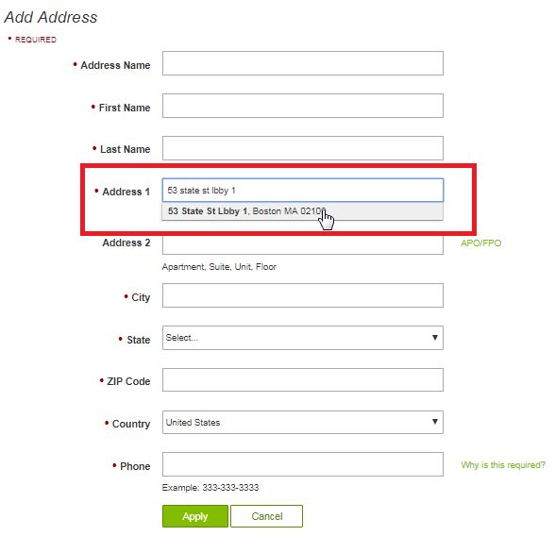

*Picture taken from sitegenesis

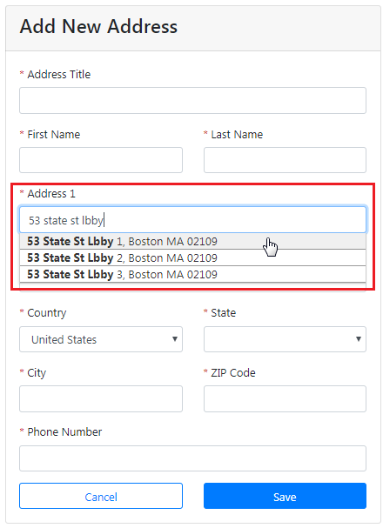

*Picture taken from SFRA

After selecting an address global intuitive automatically will fill the rest of the address fields in the form.

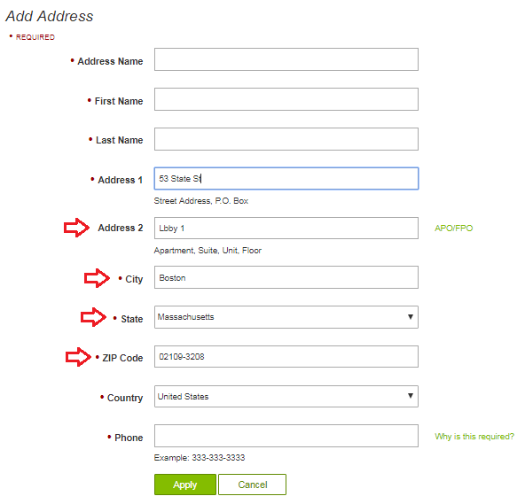

*Picture taken from sitegenesis

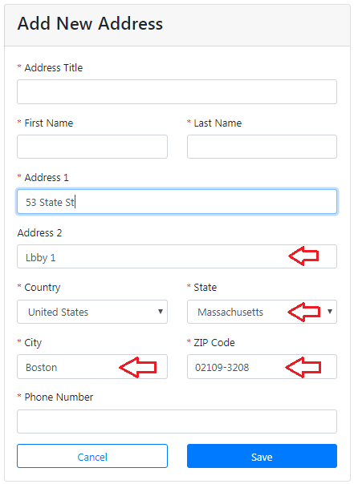

*Picture taken from SFRA

# Verification Engine

Configuration for all these tests on the Business Manager should be:

* Preferred address search engine = Verification Engine.

*This test should work with either “Both” or “Verification Engine” options.

## Test Case #1 Valid address

Once your logged into your store go to you profile and add new address; type down an address in the address input fields; for this test:

* Address 1 = 53 State st
* Address 2 = Lbby 1
* State = Massachusetts
* City = Boston
* Zip-Code = 02109-3208

Verification engine will verify and correct your address once you press the page form submitting button.

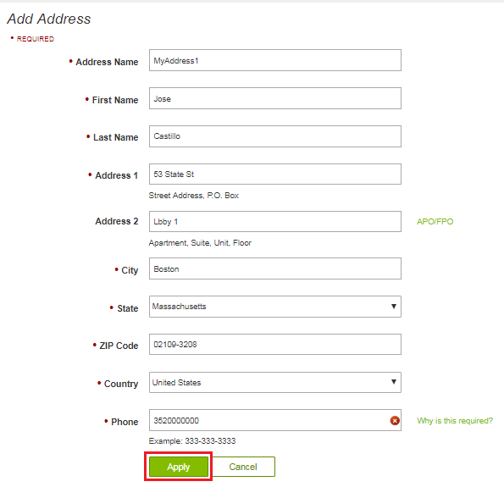

*Picture taken from SiteGenesis

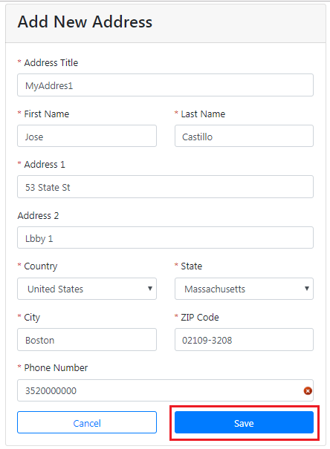

*Picture taken from SFRA

It will continue with store process workflow and save the address.

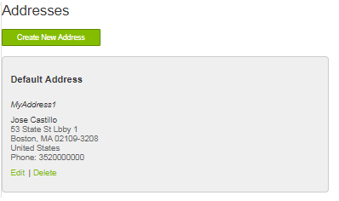

*Picture taken from SiteGenesis

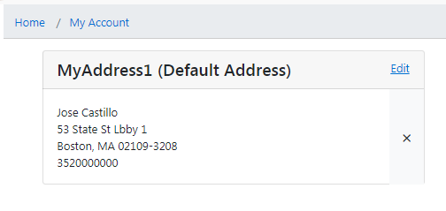

*Picture taken from SFRA

## Test Case #2 User interaction address

Once your logged into your store go to you profile and add new address; type down an address in some of the address input fields; for this test:

* Address 1 = 53 State st Lbby 1
* State = Massachusetts

Verification engine will verify and correct your address once you press the page form submitting button.

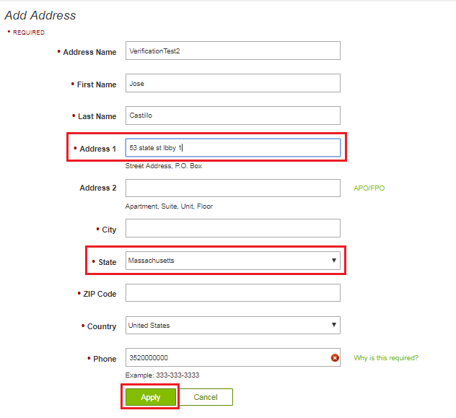

*Picture taken from SiteGenesis

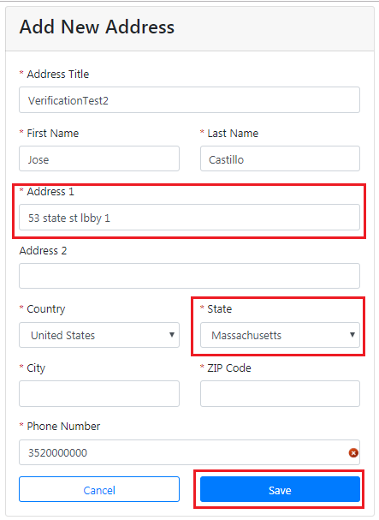

*Picture taken from SFRA

In case verification engine needs the user interaction to complete the address provided by the user; verification engine will provide an “**confirm updated address”** box; with the data provided by the user it will show a possible matching address from the one that the user typed.

In this case it will give us two options; one with the matching address provided by the verification engine or the other option to use the one typed down by the user; for this case we are going to use “**Use updated address**”; once

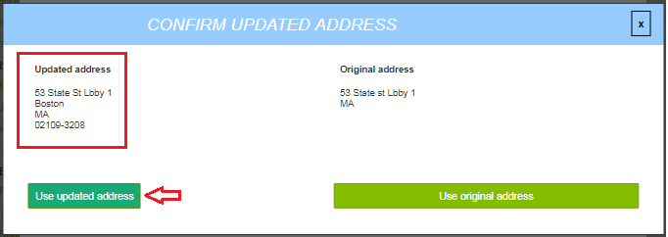

*Picture taken from SiteGenesis

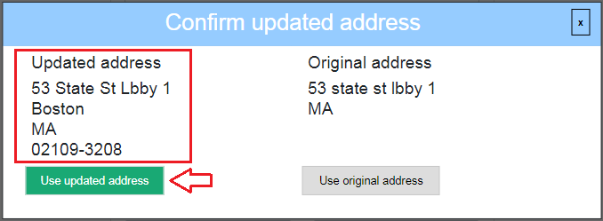

*Picture taken from SFRA

It will continue with store process workflow and save the address.

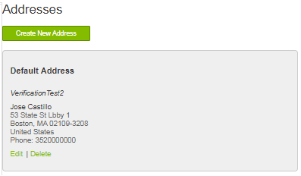

*Picture taken from SiteGenesis

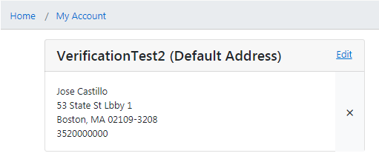

*Picture taken from SFRA

# Email Validation

## Test Case #1 Invalid email

Configuration on the Business Manager should be:

* Email Enable = Yes
* Email validation = Yes

In the create account page type down your email in the email input field in this case **thisisnotanemailxxx@gmail.com** and the email validation engine will verify your email once you lose focus on the email field, for this case it should not be a valid email so a red mark should appear on the right side of the email input field.

When this configuration is set up the Apply button (for sitegenesis) or Careate account (for SFRA) should be disabled and won’t let you get through.

When you move the mouse over the email input field again the submitting button should be reenabled again.

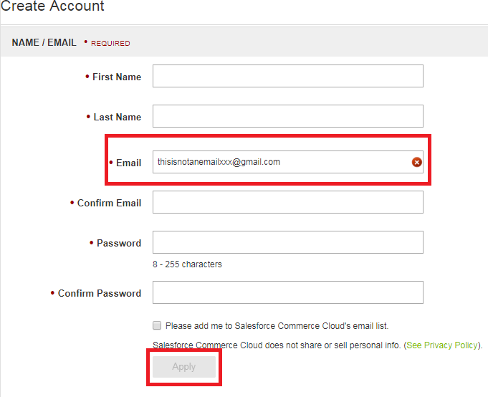

*Picture taken from sitegenesis

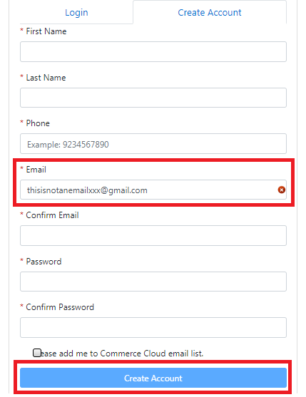

*Picture taken from SFRA

## Test Case #2 Valid email

Configuration on the Business Manager should be:

* Email Enable = Yes
* Email validation = Yes

In the create account page type down your email in the email input field in this case **jose.castillo@experian.com** and the email validation engine will verify your email once you lose focus on the email field, for this case it should be a valid email so a green mark should appear on the right side of the email input field.

When you press the submitting form button the store process should continue normally.

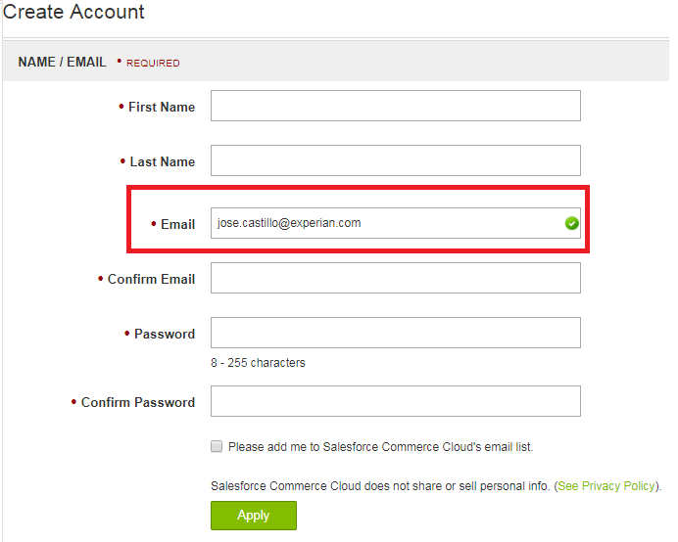

*Picture taken from sitegenesis

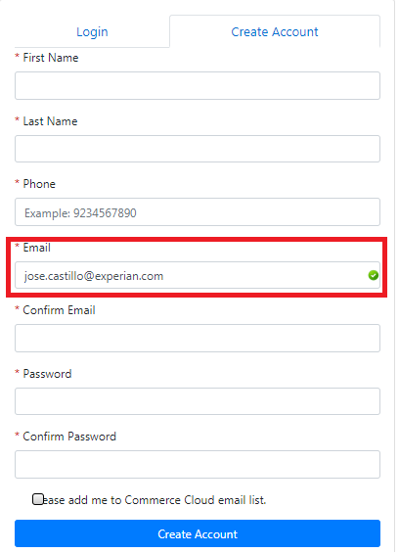

*Picture taken from SFRA

## Test Case #3 Invalid email

Configuration on the Business Manager should be:

* Email Enable = Yes
* Email validation = No

In the create account page type down your email in the email input field in this case **thisisnotanemailxxx@gmail.com** and the email validation engine will verify your email once you lose focus on the email field, for this case it should not be a valid email so a red mark should appear on the right side of the email input field.

When you press the submitting form button the store process should continue normally.

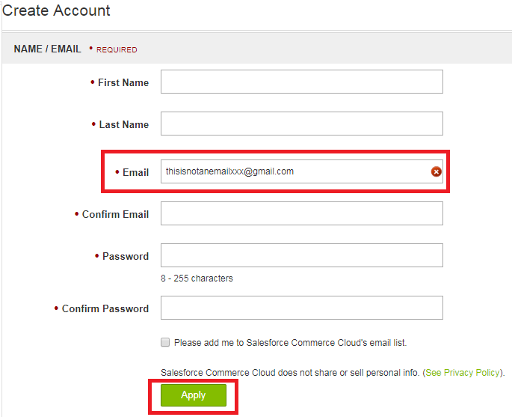

*Picture taken from sitegenesis

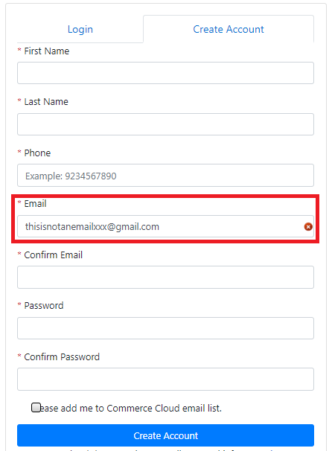

*Picture taken from SFRA

# Phone Validation

## Test Case #1 Invalid phone

Configuration on the Business Manager should be:

* Phone Enable = Yes
* Phone validation = Yes

You have to be logged into your store; go to your profile and look for the address options, in the create add new address page type down your phone in the phone input field; in this case **3520000000** and the phone validation engine will verify your phone once you lose focus on the phone field, for this case it should not be a valid phone, so a red mark should appear on the right side of the phone input field.

When this configuration is set up the Apply button (for sitegenesis) or Save (for SFRA) should be disabled and won’t let you get through.

When you move the mouse over the email input field again the submitting button should be reenabled again.

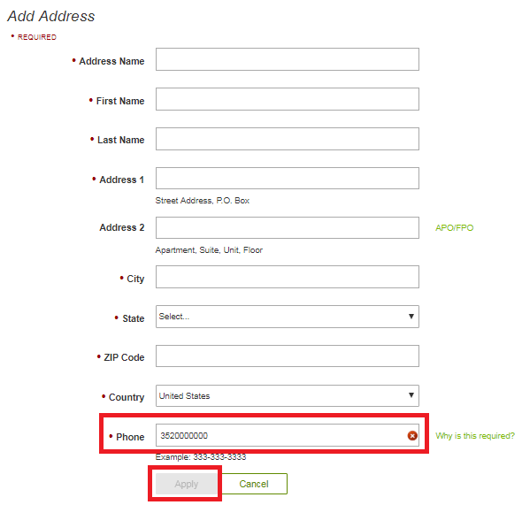

*Picture taken from sitegenesis

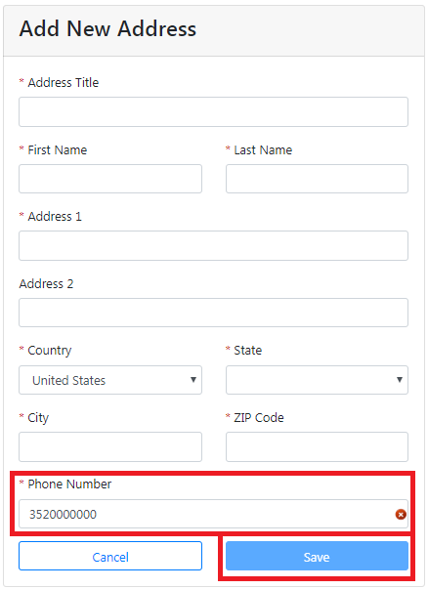

*Picture taken from SFRA

## Test Case #2 Valid phone

Configuration on the Business Manager should be:

* Phone Enable = Yes
* Phone validation = Yes

You have to be logged into your store; go to your profile and look for the address options, in the create add new address page type down your phone in the phone input field; in this case 5417543010 and the phone validation engine will verify your phone once you lose focus on the phone field, for this case it should be a valid phone, so a green mark should appear on the right side of the phone input field.

When you press the submitting form button the store process should continue normally.

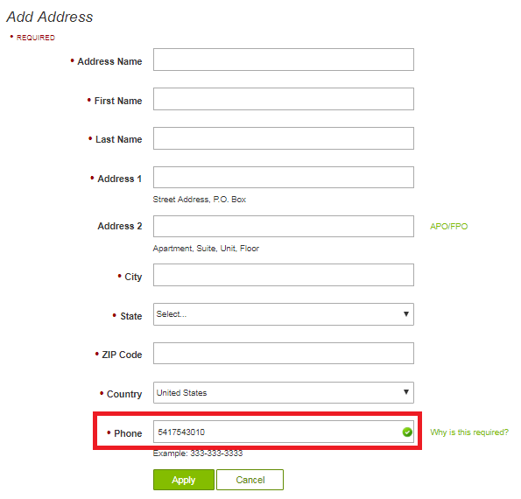

*Picture taken from sitegenesis

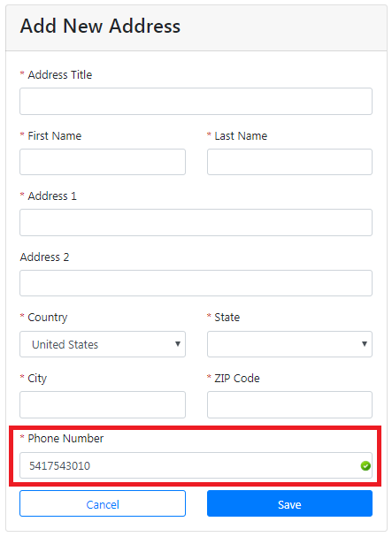

*Picture taken from SFRA

## Test Case #3 Invalid phone

Configuration on the Business Manager should be:

* Phone Enable = Yes
* Phone validation = No

You have to be logged into your store; go to your profile and look for the address options, in the create add new address page type down your phone in the phone input field; in this case **3520000000** and the phone validation engine will verify your phone once you lose focus on the phone field, for this case it should not be a valid phone, so a red mark should appear on the right side of the phone input field.

When you press the submitting form button the store process should continue normally.

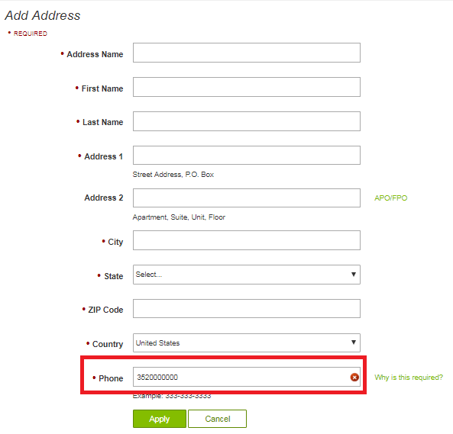

*Picture taken from sitegenesis

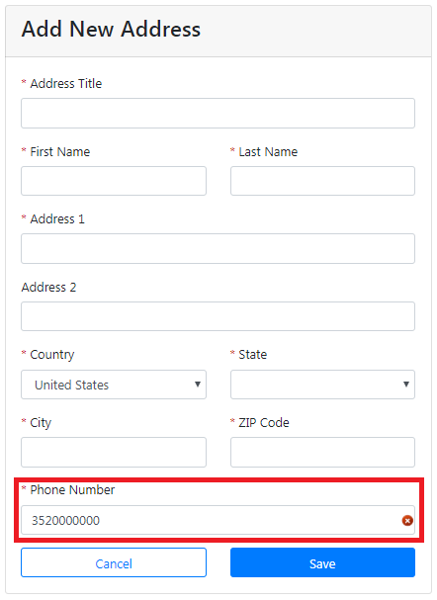

*Picture taken from SFRA